**LAMPIRAN**

Lampiran 1

Kuesioner

KUESIONER PENELITIAN

Keputusan Penggunaan Jasa Grab Food ditinjau dari Harga, Promosi, dan Citra Merek (Studi Pada Pelanggan GrabFood di Kota Surakarta)

Kepada Yth.

Bpk/Ibu/Sdr/i

Ditempat

Assalamu’alaikum Wr. Wb

Sebelumnya mohon maaf sekiranya telah mengganggu kegiatan Bapak/Ibu/Saudara saat ini. Saya mahasiswa Manajemen Fakultas Ekonomi Universitas Islam Batik Surakarta, dalam rangka menyelesaikan skripsi dengan judul **“Keputusan Penggunaan Jasa Grab Food ditinjau dari Harga, Promosi, dan Citra Merek (Studi Pada Pelanggan GrabFood di Kota Surakarta)”**. Untuk itu dimohon saudara untuk mengisi jawaban pernyataan yang saya ajukan ini.

Semua jawaban pernyataan yang Bapak/Ibu/Saudara berikan akan menjadi data yang sangat bermanfaat dalam penelitian ini. Jawaban yang Bapak/Ibu/Saudara berikan akan saya jamin kerahasiannya sesuai dengan etika penelitian.

Terimakasih atas bantuan yang telah Bapak/Ibu/Saudara berikan dalam penelitian ini, serta kesediaannya meluangkan waktu dan kerjasama nya.

Wassalamu’alaikum Wr. Wb

Hormat Saya

Eva Arnindiya Nurkharisma

**KUESIONER PENELITIAN**

Nama Responden : ………………………… (Tidak wajib diisi)

Jenis Kelamin : Laki-Laki/Perempuan (Coret yang tidak perlu)

Usia : 17-20 tahun

21-30 tahun

30-40 tahun

Pendidikan : SMA

D-III

S-I

S-II

Frekuensi Penggunaan : Hanya 1 kali

3 bulan terakhir 3-5 kali

>5 kali

**Petunjuk Pengisian**

1. Mohon memberikan tanda centang (v) pada jawaban yang menurut Bapak/Ibu/Saudara anggap paling sesuai.
2. Setiap pertanyaan mengharapkan hanya ada satu jawaban.
3. Isilah jawaban peryataan berikut ini sesuai pendapat anda dengan memberikan tanda centang (v) pada kolom yang tersedia.

Sangat Tidak Setuju (STS)

Tidak Setuju (TS)

Netral (N)

Setuju (S)

Sangat Setuju (SS)

|  |  |  |  |  |  |  |
| --- | --- | --- | --- | --- | --- | --- |
| No | **Keputusan Penggunaan** | Jawaban | | | | |
| STS | TS | N | S | SS |
| 1 | Saya menggunakan GrabFood sesuai dengan kebutuhan |  |  |  |  |  |
| 2 | Saya tertarik menggunakan GrabFood karena mendapat referensi konsumen lain |  |  |  |  |  |
| 3 | Sebelum menggunakan GrabFood saya membandingkan dengan yang lain |  |  |  |  |  |
| 4 | Menggunakan GrabFood sebagai jasa pengiriman makanan pilihan saya |  |  |  |  |  |
| 5 | Setelah menggunakan GrabFood, saya akan melakukan pembelian ulang |  |  |  |  |  |

|  |  |  |  |  |  |  |
| --- | --- | --- | --- | --- | --- | --- |
| No | **Harga** | Jawaban | | | | |
| STS | TS | N | S | SS |
| 1 | Harga yang ditawarkan oleh GrabFood terjangkau |  |  |  |  |  |
| 2 | Harga yang ditawarkan sesuai dengan kualitas jasa GrabFood |  |  |  |  |  |
| 3 | GrabFood merekomendasikan harga yang bervariasi |  |  |  |  |  |
| 4 | Harga yang ditawarkan GrabFood mampu bersaing dengan pesaingnya |  |  |  |  |  |
| 5 | Potongan harga yang ditawarkan GrabFood bermanfaat dan menguntungkan bagi saya |  |  |  |  |  |

|  |  |  |  |  |  |  |
| --- | --- | --- | --- | --- | --- | --- |
| No | **Promosi** | Jawaban | | | | |
| STS | TS | N | S | SS |
| 1 | GrabFood memiliki iklan yang ditampilkan lewat televisi maupun *social media*. |  |  |  |  |  |
| 2 | GrabFood melakukan promosi penjualan dalam bentuk diskon (potongan harga) dan *voucher* (kupon) |  |  |  |  |  |
| 3 | Adanya *voucher* dan diskon pada GrabFood membuat saya tertarik |  |  |  |  |  |
| 4 | Grab Food berpartisipasi dalam hubungan masyarakat melalui *sponsorship* dan *event* |  |  |  |  |  |
| 5 | GrabFood melakukan pemasaran langsung dengan menawarkan produk melalui pemberitahuan aplikasi GrabFood |  |  |  |  |  |

|  |  |  |  |  |  |  |
| --- | --- | --- | --- | --- | --- | --- |
| No | **Citra Merek** | Jawaban | | | | |
| STS | TS | N | S | SS |
| 1 | Merek GrabFood mudah saya ucapkan |  |  |  |  |  |
| 2 | Aplikasi GrabFood sangat mudah untuk saya gunakan |  |  |  |  |  |
| 3 | Logo GrabFood yang unik dengan dua garis berwarna hijau mudah saya ingat dan saya kenali |  |  |  |  |  |
| 4 | GrabFood merupakan jasa pengiriman makanan yang terkenal |  |  |  |  |  |
| 5 | GrabFood memiliki kredibilitas perusahaan yang baik |  |  |  |  |  |

Lampiran 2

Rekapitulasi Data Hasil Uji Instrumen

|  |  |  |  |  |  |  |  |  |  |  |  |  |
| --- | --- | --- | --- | --- | --- | --- | --- | --- | --- | --- | --- | --- |
| No | **KEPUTUSAN PENGGUNAAN** | | | | | | **HARGA** | | | | | |
| **P1** | **P2** | **P3** | **P4** | **P5** | **Y** | **P6** | **P7** | **P8** | **P9** | **P10** | **X1** |
| 1 | 5 | 4 | 5 | 4 | 5 | 23 | 4 | 5 | 5 | 5 | 5 | 24 |
| 2 | 4 | 4 | 4 | 5 | 4 | 21 | 5 | 5 | 5 | 5 | 5 | 25 |
| 3 | 4 | 3 | 4 | 3 | 4 | 18 | 4 | 4 | 4 | 4 | 4 | 20 |
| 4 | 5 | 5 | 5 | 5 | 5 | 25 | 5 | 5 | 5 | 5 | 5 | 25 |
| 5 | 5 | 5 | 5 | 5 | 5 | 25 | 5 | 5 | 5 | 5 | 5 | 25 |
| 6 | 4 | 4 | 3 | 5 | 5 | 21 | 4 | 5 | 4 | 4 | 5 | 22 |
| 7 | 5 | 5 | 5 | 5 | 5 | 25 | 5 | 5 | 5 | 5 | 5 | 25 |
| 8 | 4 | 4 | 5 | 4 | 4 | 21 | 4 | 4 | 4 | 4 | 4 | 20 |
| 9 | 5 | 4 | 5 | 3 | 3 | 20 | 4 | 4 | 3 | 4 | 5 | 20 |
| 10 | 5 | 5 | 5 | 5 | 5 | 25 | 3 | 5 | 5 | 5 | 5 | 23 |
| 11 | 5 | 5 | 5 | 5 | 5 | 25 | 5 | 5 | 5 | 5 | 5 | 25 |
| 12 | 4 | 5 | 4 | 4 | 5 | 22 | 3 | 3 | 3 | 2 | 2 | 13 |
| 13 | 4 | 4 | 4 | 4 | 4 | 20 | 4 | 4 | 5 | 5 | 5 | 23 |
| 14 | 5 | 4 | 4 | 4 | 5 | 22 | 4 | 4 | 5 | 5 | 5 | 23 |
| 15 | 4 | 2 | 5 | 3 | 4 | 18 | 3 | 3 | 4 | 3 | 3 | 16 |
| 16 | 5 | 3 | 4 | 4 | 4 | 20 | 4 | 4 | 4 | 4 | 5 | 21 |
| 17 | 5 | 5 | 5 | 5 | 5 | 25 | 5 | 5 | 5 | 5 | 5 | 25 |
| 18 | 4 | 4 | 5 | 3 | 4 | 20 | 4 | 4 | 5 | 4 | 5 | 22 |
| 19 | 4 | 5 | 4 | 5 | 5 | 23 | 5 | 5 | 5 | 5 | 5 | 25 |
| 20 | 4 | 3 | 3 | 4 | 4 | 18 | 3 | 4 | 4 | 3 | 4 | 18 |

|  |  |  |  |  |  |  |  |  |  |  |  |  |
| --- | --- | --- | --- | --- | --- | --- | --- | --- | --- | --- | --- | --- |
| No | **PROMOSI** | | | | | | **CITRA MEREK** | | | | | |
| **P11** | **P12** | **P13** | **P14** | **P15** | **X2** | **P16** | **P17** | **P18** | **P19** | **P20** | **X3** |
| 1 | 5 | 5 | 4 | 5 | 5 | 24 | 5 | 5 | 5 | 5 | 5 | 25 |
| 2 | 5 | 5 | 5 | 4 | 5 | 24 | 4 | 5 | 4 | 5 | 5 | 23 |
| 3 | 4 | 4 | 4 | 4 | 4 | 20 | 4 | 4 | 4 | 4 | 4 | 20 |
| 4 | 5 | 5 | 5 | 5 | 5 | 25 | 5 | 5 | 5 | 5 | 5 | 25 |
| 5 | 4 | 4 | 5 | 4 | 5 | 22 | 4 | 4 | 5 | 4 | 5 | 22 |
| 6 | 4 | 4 | 5 | 4 | 5 | 22 | 4 | 5 | 3 | 4 | 5 | 21 |
| 7 | 5 | 5 | 5 | 5 | 5 | 25 | 5 | 5 | 5 | 5 | 5 | 25 |
| 8 | 4 | 5 | 5 | 4 | 3 | 21 | 3 | 4 | 4 | 5 | 4 | 20 |
| 9 | 5 | 4 | 4 | 4 | 4 | 21 | 5 | 4 | 4 | 4 | 4 | 21 |
| 10 | 5 | 5 | 5 | 5 | 5 | 25 | 5 | 5 | 5 | 5 | 4 | 24 |
| 11 | 5 | 5 | 5 | 5 | 5 | 25 | 5 | 5 | 4 | 4 | 4 | 22 |
| 12 | 3 | 5 | 5 | 3 | 3 | 19 | 3 | 3 | 3 | 3 | 4 | 16 |
| 13 | 5 | 5 | 5 | 4 | 5 | 24 | 5 | 5 | 5 | 5 | 5 | 25 |
| 14 | 5 | 5 | 5 | 4 | 5 | 24 | 5 | 5 | 5 | 5 | 4 | 24 |
| 15 | 2 | 4 | 3 | 2 | 2 | 13 | 3 | 4 | 3 | 4 | 3 | 17 |
| 16 | 3 | 4 | 5 | 4 | 4 | 20 | 5 | 5 | 3 | 4 | 4 | 21 |
| 17 | 5 | 5 | 5 | 5 | 5 | 25 | 5 | 5 | 5 | 5 | 5 | 25 |
| 18 | 4 | 5 | 5 | 3 | 4 | 21 | 5 | 5 | 5 | 5 | 5 | 25 |
| 19 | 5 | 5 | 5 | 5 | 5 | 25 | 5 | 5 | 5 | 5 | 5 | 25 |
| 20 | 4 | 4 | 4 | 4 | 4 | 20 | 4 | 4 | 4 | 4 | 3 | 19 |

Lampiran 3

Hasil Uji Validitas 20 Responden

1. Uji Validitas Keputusan Penggunaan

|  |  |  |  |  |  |  |  |
| --- | --- | --- | --- | --- | --- | --- | --- |
| **Correlations** | | | | | | | |
|  | | P1 | P2 | P3 | P4 | P5 | Y = Keputusan Penggunaan |
| P1 | Pearson Correlation | 1 | .410 | .523* | .326 | .338 | .667** |
| Sig. (2-tailed) |  | .072 | .018 | .160 | .145 | .001 |
| N | 20 | 20 | 20 | 20 | 20 | 20 |
| P2 | Pearson Correlation | .410 | 1 | .320 | .707** | .644** | .887** |
| Sig. (2-tailed) | .072 |  | .169 | .000 | .002 | .000 |
| N | 20 | 20 | 20 | 20 | 20 | 20 |
| P3 | Pearson Correlation | .523* | .320 | 1 | -.024 | .063 | .494* |
| Sig. (2-tailed) | .018 | .169 |  | .919 | .791 | .027 |
| N | 20 | 20 | 20 | 20 | 20 | 20 |
| P4 | Pearson Correlation | .326 | .707** | -.024 | 1 | .717** | .784** |
| Sig. (2-tailed) | .160 | .000 | .919 |  | .000 | .000 |
| N | 20 | 20 | 20 | 20 | 20 | 20 |
| P5 | Pearson Correlation | .338 | .644** | .063 | .717** | 1 | .768** |
| Sig. (2-tailed) | .145 | .002 | .791 | .000 |  | .000 |
| N | 20 | 20 | 20 | 20 | 20 | 20 |
| Y = Keputusan Penggunaan | Pearson Correlation | .667** | .887** | .494* | .784** | .768** | 1 |
| Sig. (2-tailed) | .001 | .000 | .027 | .000 | .000 |  |
| N | 20 | 20 | 20 | 20 | 20 | 20 |
| *. Correlation is significant at the 0.05 level (2-tailed). | | | | | | | |
| **. Correlation is significant at the 0.01 level (2-tailed). | | | | | | | |

1. Uji Validitas Harga

|  |  |  |  |  |  |  |  |  |
| --- | --- | --- | --- | --- | --- | --- | --- | --- |
| **Correlations** | | | | | | | | |
|  | | P6 | P7 | P8 | P9 | P10 | X1 = Harga |
| P6 | Pearson Correlation | 1 | .706** | .564** | .722** | .620** | .817** |
| Sig. (2-tailed) |  | .001 | .010 | .000 | .004 | .000 |
| N | 20 | 20 | 20 | 20 | 20 | 20 |
| P7 | Pearson Correlation | .706** | 1 | .674** | .813** | .773** | .895** |
| Sig. (2-tailed) | .001 |  | .001 | .000 | .000 | .000 |
| N | 20 | 20 | 20 | 20 | 20 | 20 |
| P8 | Pearson Correlation | .564** | .674** | 1 | .830** | .652** | .839** |
| Sig. (2-tailed) | .010 | .001 |  | .000 | .002 | .000 |
| N | 20 | 20 | 20 | 20 | 20 | 20 |
| P9 | Pearson Correlation | .722** | .813** | .830** | 1 | .865** | .963** |
| Sig. (2-tailed) | .000 | .000 | .000 |  | .000 | .000 |
| N | 20 | 20 | 20 | 20 | 20 | 20 |
| P10 | Pearson Correlation | .620** | .773** | .652** | .865** | 1 | .894** |
| Sig. (2-tailed) | .004 | .000 | .002 | .000 |  | .000 |
| N | 20 | 20 | 20 | 20 | 20 | 20 |
| X1 = Harga | Pearson Correlation | .817** | .895** | .839** | .963** | .894** | 1 |
| Sig. (2-tailed) | .000 | .000 | .000 | .000 | .000 |  |
| N | 20 | 20 | 20 | 20 | 20 | 20 |
| **. Correlation is significant at the 0.01 level (2-tailed). | | | | | | | | |

1. Uji Validitas Promosi

|  |  |  |  |  |  |  |  |
| --- | --- | --- | --- | --- | --- | --- | --- |
| **Correlations** | | | | | | | |
|  | | P11 | P12 | P13 | P14 | P15 | X2 = Promosi |
| P11 | Pearson Correlation | 1 | .547* | .432 | .810** | .831** | .920** |
| Sig. (2-tailed) |  | .013 | .057 | .000 | .000 | .000 |
| N | 20 | 20 | 20 | 20 | 20 | 20 |
| P12 | Pearson Correlation | .547* | 1 | .546* | .404 | .341 | .631** |
| Sig. (2-tailed) | .013 |  | .013 | .078 | .141 | .003 |
| N | 20 | 20 | 20 | 20 | 20 | 20 |
| P13 | Pearson Correlation | .432 | .546* | 1 | .442 | .564** | .686** |
| Sig. (2-tailed) | .057 | .013 |  | .051 | .010 | .001 |
| N | 20 | 20 | 20 | 20 | 20 | 20 |
| P14 | Pearson Correlation | .810** | .404 | .442 | 1 | .792** | .883** |
| Sig. (2-tailed) | .000 | .078 | .051 |  | .000 | .000 |
| N | 20 | 20 | 20 | 20 | 20 | 20 |
| P15 | Pearson Correlation | .831** | .341 | .564** | .792** | 1 | .907** |
| Sig. (2-tailed) | .000 | .141 | .010 | .000 |  | .000 |
| N | 20 | 20 | 20 | 20 | 20 | 20 |
| X2 = Promosi | Pearson Correlation | .920** | .631** | .686** | .883** | .907** | 1 |
| Sig. (2-tailed) | .000 | .003 | .001 | .000 | .000 |  |
| N | 20 | 20 | 20 | 20 | 20 | 20 |
| *. Correlation is significant at the 0.05 level (2-tailed). | | | | | | | |
| **. Correlation is significant at the 0.01 level (2-tailed). | | | | | | | |

1. Uji Validitas Citra Merek

|  |  |  |  |  |  |  |  |
| --- | --- | --- | --- | --- | --- | --- | --- |
| **Correlations** | | | | | | | |
|  | | P16 | P17 | P18 | P19 | P20 | X3 = Citra Merek |
| P16 | Pearson Correlation | 1 | .765** | .632** | .514* | .448* | .828** |
| Sig. (2-tailed) |  | .000 | .003 | .020 | .047 | .000 |
| N | 20 | 20 | 20 | 20 | 20 | 20 |
| P17 | Pearson Correlation | .765** | 1 | .483* | .725** | .543* | .841** |
| Sig. (2-tailed) | .000 |  | .031 | .000 | .013 | .000 |
| N | 20 | 20 | 20 | 20 | 20 | 20 |
| P18 | Pearson Correlation | .632** | .483* | 1 | .757** | .540* | .848** |
| Sig. (2-tailed) | .003 | .031 |  | .000 | .014 | .000 |
| N | 20 | 20 | 20 | 20 | 20 | 20 |
| P19 | Pearson Correlation | .514* | .725** | .757** | 1 | .510* | .844** |
| Sig. (2-tailed) | .020 | .000 | .000 |  | .022 | .000 |
| N | 20 | 20 | 20 | 20 | 20 | 20 |
| P20 | Pearson Correlation | .448* | .543* | .540* | .510* | 1 | .739** |
| Sig. (2-tailed) | .047 | .013 | .014 | .022 |  | .000 |
| N | 20 | 20 | 20 | 20 | 20 | 20 |
| X3 = Citra Merek | Pearson Correlation | .828** | .841** | .848** | .844** | .739** | 1 |
| Sig. (2-tailed) | .000 | .000 | .000 | .000 | .000 |  |
| N | 20 | 20 | 20 | 20 | 20 | 20 |
| **. Correlation is significant at the 0.01 level (2-tailed). | | | | | | | |
| *. Correlation is significant at the 0.05 level (2-tailed). | | | | | | | |

Lampiran 4

Hasil Uji Reliabilitas 20 Responden

|  |  |  |  |
| --- | --- | --- | --- |
| **Case Processing Summary** | | | |
|  | | N | % |
| Cases | Valid | 20 | 100.0 |
| Excludeda | 0 | .0 |
| Total | 20 | 100.0 |
| a. Listwise deletion based on all variables in the procedure. | | | |

1. Uji Reliabilitas Keputusan Penggunaan

|  |  |
| --- | --- |
| **Reliability Statistics** | |
| Cronbach's Alpha | N of Items |
| .768 | 5 |

1. Uji Reliabilitas Harga

|  |  |
| --- | --- |
| **Reliability Statistics** | |
| Cronbach's Alpha | N of Items |
| .928 | 5 |

1. Uji Reliabilitas Promosi

|  |  |
| --- | --- |
| **Reliability Statistics** | |
| Cronbach's Alpha | N of Items |
| .871 | 5 |

1. Uji Reliabilitas Citra Merek

|  |  |
| --- | --- |
| **Reliability Statistics** | |
| Cronbach's Alpha | N of Items |
| .873 | 5 |

Lampiran 5

TABULASI SKORING RESPONDEN





Lampiran 6

Hasil Uji Asumsi Klasik

1. Uji Normalitas

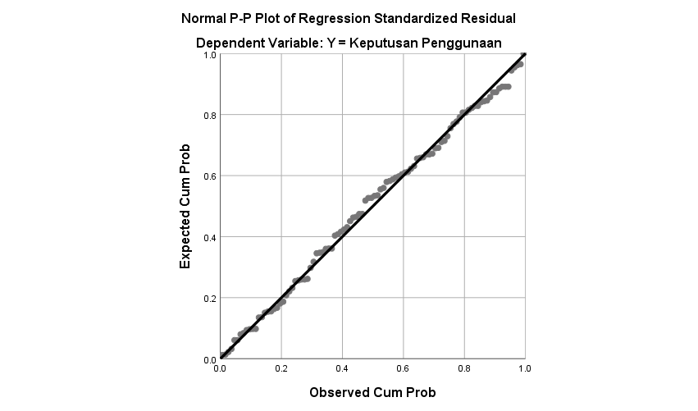

|  |  |  |
| --- | --- | --- |
| **One-Sample Kolmogorov-Smirnov Test** | | |
|  | | Unstandardized Residual |
| N | | 100 |
| Normal Parametersa,b | Mean | .0000000 |
| Std. Deviation | 1.81753305 |
| Most Extreme Differences | Absolute | .055 |
| Positive | .055 |
| Negative | -.048 |
| Test Statistic | | .055 |
| Asymp. Sig. (2-tailed) | | .200c,d |
| a. Test distribution is Normal. | | |
| b. Calculated from data. | | |

1. Uji Multikolinieritas

|  |  |  |  |  |  |  |  |  |
| --- | --- | --- | --- | --- | --- | --- | --- | --- |
| **Coefficientsa** | | | | | | | | |
| Model | | Unstandardized Coefficients | | Standardized Coefficients | t | Sig. | Collinearity Statistics | |
| B | Std. Error | Beta | Tolerance | VIF |
| 1 | (Constant) | 5.056 | 1.466 |  | 3.449 | .001 |  |  |
| X1 = Harga | .424 | .091 | .475 | 4.649 | .000 | .471 | 2.125 |
| X2 = Promosi | .061 | .108 | .066 | .565 | .573 | .364 | 2.749 |
| X3 = Citra Merek | .221 | .107 | .251 | 2.068 | .041 | .333 | 3.000 |
| a. Dependent Variable: Y = Keputusan Penggunaan | | | | | | | | |

1. Uji Heterokedastisitas

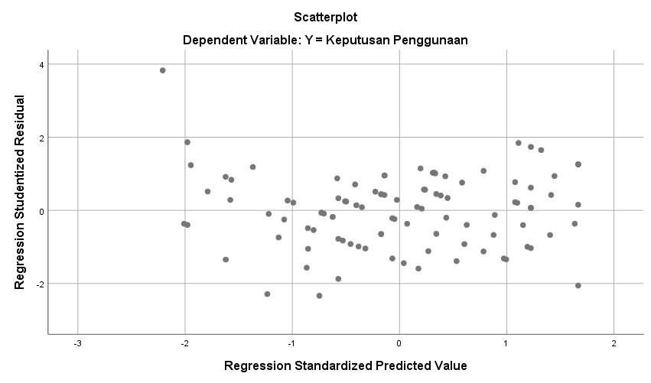

Lampiran 7

Hasil Uji Regresi Linear Berganda

|  |  |  |  |  |  |  |
| --- | --- | --- | --- | --- | --- | --- |
| **ANOVAa** | | | | | | |
| Model | | Sum of Squares | df | Mean Square | F | Sig. |
| 1 | Regression | 365.921 | 3 | 121.974 | 35.804 | .000b |
| Residual | 327.039 | 96 | 3.407 |  |  |
| Total | 692.960 | 99 |  |  |  |
| a. Dependent Variable: Y = Keputusan Penggunaan | | | | | | |
| b. Predictors: (Constant), X3 = Citra Merek, X1 = Harga, X2 = Promosi | | | | | | |

1. Uji F
2. Uji t

|  |  |  |  |  |  |  |
| --- | --- | --- | --- | --- | --- | --- |
| **Coefficientsa** | | | | | | |
| Model | | Unstandardized Coefficients | | Standardized Coefficients | t | Sig. |
| B | Std. Error | Beta |
| 1 | (Constant) | 5.056 | 1.466 |  | 3.449 | .001 |
| X1 = Harga | .424 | .091 | .475 | 4.649 | .000 |
| X2 = Promosi | .061 | .108 | .066 | .565 | .573 |
| X3 = Citra Merek | .221 | .107 | .251 | 2.068 | .041 |
| a. Dependent Variable: Y = Keputusan Penggunaan | | | | | | |

1. Uji Koefisien Determinasi ( R² )

|  |  |  |  |  |
| --- | --- | --- | --- | --- |
| **Model Summary** | | | | |
| Model | R | R Square | Adjusted R Square | Std. Error of the Estimate |
| 1 | .727a | .528 | .513 | 1.846 |
| a. Predictors: (Constant), X3 = Citra Merek, X1 = Harga, X2 = Promosi | | | | |

Lampiran 8

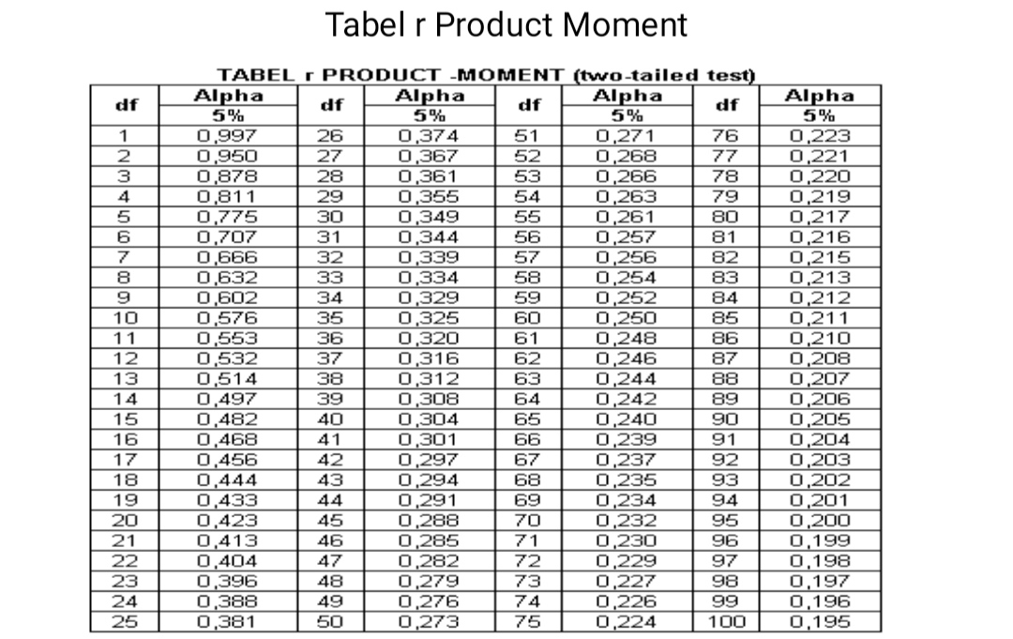

Lampiran 9

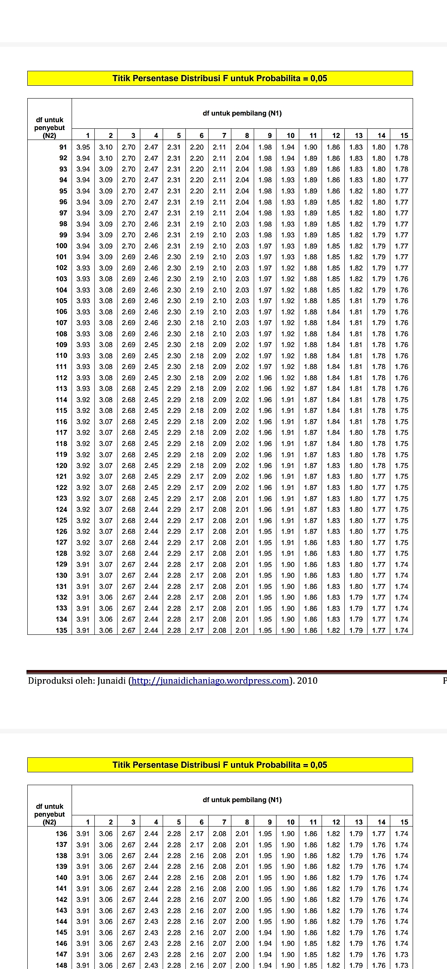

Lampiran 10

