VALIDITAS

FILE='D:\DATA S2\MBAK RENI\Untitled1.sav'.
DATASET NAME DataSet1 WINDOW=FRONT.
CORRELATIONS
/VARIABLES=Kiner_1 Kiner_2 Kiner_3 Kiner_4 Kiner_5 Tot_Kinerja
/PRINT=TWOTAIL NOSIG
/MISSING=PAIRWISE.

Correlations

Notes
Output Created |  | 02-JUL-2021 08:01:37
Comments
Input | Data | D:\DATA S2\MBAK RENI\Untitled1.sav
 | Active Dataset | DataSet1
 | Filter | <none>
 | Weight | <none>
 | Split File | <none>
 | N of Rows in Working Data File | 20
Missing Value Handling | Definition of Missing | User-defined missing values are treated as missing.
 | Cases Used | Statistics for each pair of variables are based on all the cases with valid data for that pair.
Syntax |  | CORRELATIONS  /VARIABLES=Kiner_1 Kiner_2 Kiner_3 Kiner_4 Kiner_5 Tot_Kinerja  /PRINT=TWOTAIL NOSIG  /MISSING=PAIRWISE.
Resources | Processor Time | 00:00:00,02
 | Elapsed Time | 00:00:00,02

[DataSet1] D:\DATA S2\Untitled1.sav

- UJI VALIDITAS VARIABEL KINERJA

Correlations
 |  | Kiner_1 | Kiner_2 | Kiner_3 | Kiner_4 | Kiner_5 | Tot_Kinerja
Kiner_1 | Pearson Correlation | 1 | .577** | .577** | .638** | .365 | .769**
 | Sig. (2-tailed) |  | .008 | .008 | .002 | .113 | .000
 | N | 20 | 20 | 20 | 20 | 20 | 20
Kiner_2 | Pearson Correlation | .577** | 1 | .600** | .704** | .316 | .789**
 | Sig. (2-tailed) | .008 |  | .005 | .001 | .174 | .000
 | N | 20 | 20 | 20 | 20 | 20 | 20
Kiner_3 | Pearson Correlation | .577** | .600** | 1 | .905** | .474* | .888**
 | Sig. (2-tailed) | .008 | .005 |  | .000 | .035 | .000
 | N | 20 | 20 | 20 | 20 | 20 | 20
Kiner_4 | Pearson Correlation | .638** | .704** | .905** | 1 | .318 | .877**
 | Sig. (2-tailed) | .002 | .001 | .000 |  | .172 | .000
 | N | 20 | 20 | 20 | 20 | 20 | 20
Kiner_5 | Pearson Correlation | .365 | .316 | .474* | .318 | 1 | .663**
 | Sig. (2-tailed) | .113 | .174 | .035 | .172 |  | .001
 | N | 20 | 20 | 20 | 20 | 20 | 20
Tot_Kinerja | Pearson Correlation | .769** | .789** | .888** | .877** | .663** | 1
 | Sig. (2-tailed) | .000 | .000 | .000 | .000 | .001
 | N | 20 | 20 | 20 | 20 | 20 | 20
**. Correlation is significant at the 0.01 level (2-tailed).
*. Correlation is significant at the 0.05 level (2-tailed).

- UJI VALIDITAS VARIABEL SUPERVISI

Correlations
 |  | Super_1 | Super_2 | Super_3 | Super_4 | Tot_Super
Super_1 | Pearson Correlation | 1 | .571** | .136 | .644** | .705**
 | Sig. (2-tailed) |  | .008 | .568 | .002 | .001
 | N | 20 | 20 | 20 | 20 | 20
Super_2 | Pearson Correlation | .571** | 1 | .259 | .524* | .705**
 | Sig. (2-tailed) | .008 |  | .270 | .018 | .001
 | N | 20 | 20 | 20 | 20 | 20
Super_3 | Pearson Correlation | .136 | .259 | 1 | .290 | .739**
 | Sig. (2-tailed) | .568 | .270 |  | .215 | .000
 | N | 20 | 20 | 20 | 20 | 20
Super_4 | Pearson Correlation | .644** | .524* | .290 | 1 | .742**
 | Sig. (2-tailed) | .002 | .018 | .215 |  | .000
 | N | 20 | 20 | 20 | 20 | 20
Tot_Super | Pearson Correlation | .705** | .705** | .739** | .742** | 1
 | Sig. (2-tailed) | .001 | .001 | .000 | .000
 | N | 20 | 20 | 20 | 20 | 20
**. Correlation is significant at the 0.01 level (2-tailed).
*. Correlation is significant at the 0.05 level (2-tailed).

- UJI VALIDITAS VARIABEL INTEGRITAS

Correlations
 |  | Integ_1 | Integ_2 | Integ_3 | Integ_4 | Integ_5 | Tot_Integ
Integ_1 | Pearson Correlation | 1 | .524* | .257 | .089 | .314 | .545*
 | Sig. (2-tailed) |  | .018 | .274 | .710 | .177 | .013
 | N | 20 | 20 | 20 | 20 | 20 | 20
Integ_2 | Pearson Correlation | .524* | 1 | .612** | .507* | .800** | .888**
 | Sig. (2-tailed) | .018 |  | .004 | .022 | .000 | .000
 | N | 20 | 20 | 20 | 20 | 20 | 20
Integ_3 | Pearson Correlation | .257 | .612** | 1 | .518* | .612** | .776**
 | Sig. (2-tailed) | .274 | .004 |  | .019 | .004 | .000
 | N | 20 | 20 | 20 | 20 | 20 | 20
Integ_4 | Pearson Correlation | .089 | .507* | .518* | 1 | .676** | .750**
 | Sig. (2-tailed) | .710 | .022 | .019 |  | .001 | .000
 | N | 20 | 20 | 20 | 20 | 20 | 20
Integ_5 | Pearson Correlation | .314 | .800** | .612** | .676** | 1 | .888**
 | Sig. (2-tailed) | .177 | .000 | .004 | .001 |  | .000
 | N | 20 | 20 | 20 | 20 | 20 | 20
Tot_Integ | Pearson Correlation | .545* | .888** | .776** | .750** | .888** | 1
 | Sig. (2-tailed) | .013 | .000 | .000 | .000 | .000
 | N | 20 | 20 | 20 | 20 | 20 | 20
*. Correlation is significant at the 0.05 level (2-tailed).
**. Correlation is significant at the 0.01 level (2-tailed).

- UJI VALIDITAS VARIABEL BUDAYA ORGANISASI

Correlations
 |  | Bud_1 | Bud_2 | Bud_3 | Bud_4 | Bud_5 | Tot_Bud
Bud_1 | Pearson Correlation | 1 | .685** | .601** | .650** | .635** | .827**
 | Sig. (2-tailed) |  | .001 | .005 | .002 | .003 | .000
 | N | 20 | 20 | 20 | 20 | 20 | 20
Bud_2 | Pearson Correlation | .685** | 1 | .698** | .749** | .571** | .861**
 | Sig. (2-tailed) | .001 |  | .001 | .000 | .009 | .000
 | N | 20 | 20 | 20 | 20 | 20 | 20
Bud_3 | Pearson Correlation | .601** | .698** | 1 | .676** | .703** | .857**
 | Sig. (2-tailed) | .005 | .001 |  | .001 | .001 | .000
 | N | 20 | 20 | 20 | 20 | 20 | 20
Bud_4 | Pearson Correlation | .650** | .749** | .676** | 1 | .693** | .888**
 | Sig. (2-tailed) | .002 | .000 | .001 |  | .001 | .000
 | N | 20 | 20 | 20 | 20 | 20 | 20
Bud_5 | Pearson Correlation | .635** | .571** | .703** | .693** | 1 | .846**
 | Sig. (2-tailed) | .003 | .009 | .001 | .001 |  | .000
 | N | 20 | 20 | 20 | 20 | 20 | 20
Tot_Bud | Pearson Correlation | .827** | .861** | .857** | .888** | .846** | 1
 | Sig. (2-tailed) | .000 | .000 | .000 | .000 | .000
 | N | 20 | 20 | 20 | 20 | 20 | 20
**. Correlation is significant at the 0.01 level (2-tailed).

- UJI VALIDITAS VARIABEL ETOS KERJA

Correlations
 |  | Etos_1 | Etos_2 | Etos_3 | Etos_4 | Etos_5 | Tot_Etos
Etos_1 | Pearson Correlation | 1 | .811** | .811** | .664** | .471* | .855**
 | Sig. (2-tailed) |  | .000 | .000 | .001 | .036 | .000
 | N | 20 | 20 | 20 | 20 | 20 | 20
Etos_2 | Pearson Correlation | .811** | 1 | .798** | .818** | .492* | .894**
 | Sig. (2-tailed) | .000 |  | .000 | .000 | .027 | .000
 | N | 20 | 20 | 20 | 20 | 20 | 20
Etos_3 | Pearson Correlation | .811** | .798** | 1 | .818** | .698** | .940**
 | Sig. (2-tailed) | .000 | .000 |  | .000 | .001 | .000
 | N | 20 | 20 | 20 | 20 | 20 | 20
Etos_4 | Pearson Correlation | .664** | .818** | .818** | 1 | .739** | .922**
 | Sig. (2-tailed) | .001 | .000 | .000 |  | .000 | .000
 | N | 20 | 20 | 20 | 20 | 20 | 20
Etos_5 | Pearson Correlation | .471* | .492* | .698** | .739** | 1 | .775**
 | Sig. (2-tailed) | .036 | .027 | .001 | .000 |  | .000
 | N | 20 | 20 | 20 | 20 | 20 | 20
Tot_Etos | Pearson Correlation | .855** | .894** | .940** | .922** | .775** | 1
 | Sig. (2-tailed) | .000 | .000 | .000 | .000 | .000
 | N | 20 | 20 | 20 | 20 | 20 | 20
**. Correlation is significant at the 0.01 level (2-tailed).
*. Correlation is significant at the 0.05 level (2-tailed).

RELIABILITAS

RELIABILITY
/VARIABLES=Kiner_1 Kiner_2 Kiner_3 Kiner_4 Kiner_5
/SCALE('ALL VARIABLES') ALL
/MODEL=ALPHA.

Reliability

Notes
Output Created |  | 02-JUL-2021 08:07:02
Comments
Input | Data | D:\DATA S2\MBAK RENI\Untitled1.sav
 | Active Dataset | DataSet1
 | Filter | <none>
 | Weight | <none>
 | Split File | <none>
 | N of Rows in Working Data File | 20
 | Matrix Input
Missing Value Handling | Definition of Missing | User-defined missing values are treated as missing.
 | Cases Used | Statistics are based on all cases with valid data for all variables in the procedure.
Syntax |  | RELIABILITY  /VARIABLES=Kiner_1 Kiner_2 Kiner_3 Kiner_4 Kiner_5  /SCALE('ALL VARIABLES') ALL  /MODEL=ALPHA.
Resources | Processor Time | 00:00:00,00
 | Elapsed Time | 00:00:00,00

- UJI RELIABILITAS VARIABEL KINERJA

Scale: ALL VARIABLES

Case Processing Summary
 |  | N | %
Cases | Valid | 20 | 100.0
 | Excludedª | 0 | .0
 | Total | 20 | 100.0
a. Listwise deletion based on all variables in the procedure.

Reliability Statistics
Cronbach's Alpha | N of Items
.844 | 5

- UJI RELIABILITAS VARIABEL SUPERVISI

Scale: ALL VARIABLES

Case Processing Summary
 |  | N | %
Cases | Valid | 20 | 100.0
 | Excludedª | 0 | .0
 | Total | 20 | 100.0
a. Listwise deletion based on all variables in the procedure.

Reliability Statistics
Cronbach's Alpha | N of Items
.606 | 4

- UJI RELIABILITAS VARIABEL INTEGRITAS

Scale: ALL VARIABLES

Case Processing Summary
 |  | N | %
Cases | Valid | 20 | 100.0
 | Excludedª | 0 | .0
 | Total | 20 | 100.0
a. Listwise deletion based on all variables in the procedure.

Reliability Statistics
Cronbach's Alpha | N of Items
.826 | 5

- UJI RELIABILITAS VARIABEL BUDAYA ORGANISASI

Scale: ALL VARIABLES

Case Processing Summary
 |  | N | %
Cases | Valid | 20 | 100.0
 | Excludedª | 0 | .0
 | Total | 20 | 100.0
a. Listwise deletion based on all variables in the procedure.

Reliability Statistics
Cronbach's Alpha | N of Items
.908 | 5

- UJI RELIABILITAS VARIABEL ETOS KERJA

Scale: ALL VARIABLES

Case Processing Summary
 |  | N | %
Cases | Valid | 20 | 100.0
 | Excludedª | 0 | .0
 | Total | 20 | 100.0
a. Listwise deletion based on all variables in the procedure.

Reliability Statistics
Cronbach's Alpha | N of Items
.925 | 5

DESKRIPSI RESPONDEN
1. | Berdasarkan Umur
 | Umur | Jumlah | Persentase (%)
 | < 30 Tahun | 22 | 24,44444444
 | 31 - 40 Tahun | 29 | 32,22222222
 | 41 - 50 Tahun | 22 | 24,44444444
 | >50 Tahun | 17 | 18,88888889
 | Jumlah | 90 | 100
2. | Berdasarkan Jenis kelamin
 | Jenis Kelamin | Jumlah | Persentase (%)
 | Laki-laki | 52 | 57,77777778
 | Perempuan | 38 | 42,22222222
 | Jumlah | 90 | 100
3. | Berdasarkan Masa Kerja
 | Pengalaman Kerja | Jumlah | Persentase (%)
 | < 5 tahun | 22 | 24,44444444
 | 6 – 10 Tahun | 9 | 10
 | 11 - 20 Tahun | 49 | 54,44444444
 | >20 Tahun | 10 | 11,11111111
 | Jumlah | 90 | 100

UJI ASUMSI KLASIK

UJI NORMALITAS

REGRESSION
/MISSING LISTWISE
/STATISTICS COEFF OUTS R ANOVA COLLIN TOL
/CRITERIA=PIN(.05) POUT(.10)
/NOORIGIN
/DEPENDENT Kinerja
/METHOD=ENTER Supervisi Integritas Budaya_Org Etos_Kerja
/SAVE RESID.

Regression
Notes
Output Created |  | 03-JUL-2021 17:14:28
Comments
Input | Data | D:\DATA S2\MBAK RENI\Data asumsi klasik.sav
 | Active Dataset | DataSet1
 | Filter | <none>
 | Weight | <none>
 | Split File | <none>
 | N of Rows in Working Data File | 90
Missing Value Handling | Definition of Missing | User-defined missing values are treated as missing.
 | Cases Used | Statistics are based on cases with no missing values for any variable used.
Syntax |  | REGRESSION  /MISSING LISTWISE  /STATISTICS COEFF OUTS R ANOVA COLLIN TOL  /CRITERIA=PIN(.05) POUT(.10)  /NOORIGIN  /DEPENDENT Kinerja  /METHOD=ENTER Supervisi Integritas Budaya_Org Etos_Kerja  /SAVE RESID.
Resources | Processor Time | 00:00:00,03
 | Elapsed Time | 00:00:00,07
 | Memory Required | 4112 bytes
 | Additional Memory Required for Residual Plots | 0 bytes
Variables Created or Modified | RES_1 | Unstandardized Residual

NPar Tests

One-Sample Kolmogorov-Smirnov Test
 |  | Unstandardized Residual
N |  | 90
Normal Parameters^{a,b} | Mean | .0000000
 | Std. Deviation | 1.29141684
Most Extreme Differences | Absolute | .097
 | Positive | .092
 | Negative | -.097
Test Statistic |  | .097
Asymp. Sig. (2-tailed) |  | .037^{c}
a. Test distribution is Normal.
b. Calculated from data.
c. Lilliefors Significance Correction.

Charts

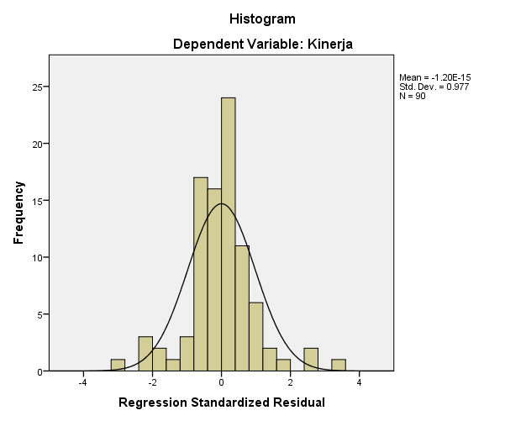
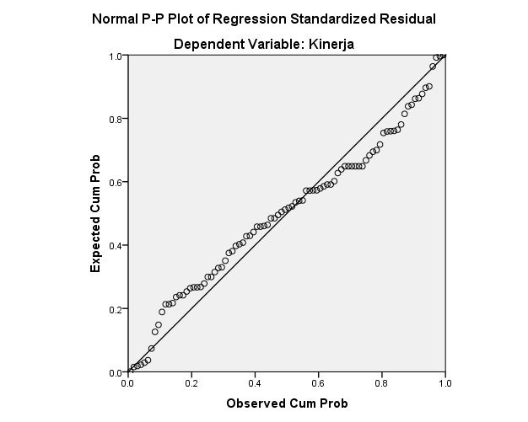

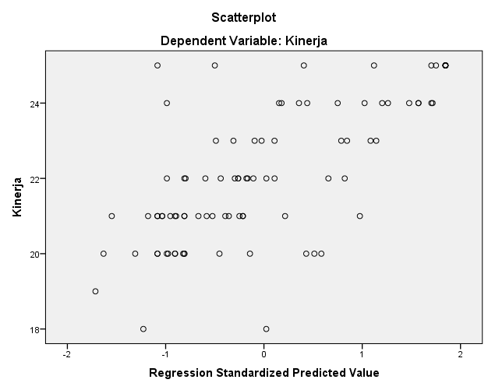

UJI MULTIKOLINEARITAS

REGRESSION
/MISSING LISTWISE
/STATISTICS COEFF OUTS R ANOVA COLLIN TOL
/CRITERIA=PIN(.05) POUT(.10)
/NOORIGIN
/DEPENDENT Kinerja
/METHOD=ENTER Supervisi Integritas Budaya_Org Etos_Kerja
/SCATTERPLOT=(Kinerja ,*ZPRED)
/RESIDUALS HISTOGRAM(ZRESID) NORMPROB(ZRESID)
/SAVE RESID.

Regression

Notes
Output Created |  | 03-JUL-2021 17:28:07
Comments
Input | Data | D:\DATA S2\MBAK RENI\Data asumsi klasik.sav
 | Active Dataset | DataSet1
 | Filter | <none>
 | Weight | <none>
 | Split File | <none>
 | N of Rows in Working Data File | 90
Missing Value Handling | Definition of Missing | User-defined missing values are treated as missing.
 | Cases Used | Statistics are based on cases with no missing values for any variable used.
Syntax |  | REGRESSION  /MISSING LISTWISE  /STATISTICS COEFF OUTS R ANOVA COLLIN TOL  /CRITERIA=PIN(.05) POUT(.10)  /NOORIGIN  /DEPENDENT Kinerja  /METHOD=ENTER Supervisi Integritas Budaya_Org Etos_Kerja  /SCATTERPLOT=(Kinerja ,*ZPRED)  /RESIDUALS HISTOGRAM(ZRESID) NORMPROB(ZRESID)  /SAVE RESID.
Resources | Processor Time | 00:00:01,03
 | Elapsed Time | 00:00:00,52
 | Memory Required | 4112 bytes
 | Additional Memory Required for Residual Plots | 632 bytes
Variables Created or Modified | RES_1 | Unstandardized Residual

Variables Entered/Removedª
Model | Variables Entered | Variables Removed | Method
1 | Etos_Kerja, Supervisi, Budaya_Org, Integritas^{b} | . | Enter
a. Dependent Variable: Kinerja
b. All requested variables entered.

Model Summary^{b}
Model | R | R Square | Adjusted R Square | Std. Error of the Estimate
1 | .709ª | .502 | .479 | 1.321
a. Predictors: (Constant), Etos_Kerja, Supervisi, Budaya_Org, Integritas
b. Dependent Variable: Kinerja

ANOVAª
Model |  | Sum of Squares | df | Mean Square | F | Sig.
1 | Regression | 149.670 | 4 | 37.417 | 21.427 | .000^{b}
 | Residual | 148.430 | 85 | 1.746
 | Total | 298.100 | 89
a. Dependent Variable: Kinerja
b. Predictors: (Constant), Etos_Kerja, Supervisi, Budaya_Org, Integritas

Coefficientsª
Model |  | Unstandardized Coefficients |  | Standardized Coefficients | t | Sig. | Collinearity Statistics
 |  | B | Std. Error | Beta |  |  | Tolerance | VIF
1 | (Constant) | 5.496 | 1.891 |  | 2.907 | .005
 | Supervisi | .062 | .098 | .059 | 2.634 | .028 | .684 | 1.462
 | Integritas | .479 | .115 | .499 | 4.166 | .000 | .408 | 2.451
 | Budaya_Org | .170 | .105 | .183 | 3.619 | .009 | .458 | 2.183
 | Etos_Kerja | .061 | .122 | .063 | 2.506 | .014 | .374 | 2.673
a. Dependent Variable: Kinerja

Collinearity Diagnosticsª
Model | Dimension | Eigenvalue | Condition Index | Variance Proportions
 |  |  |  | (Constant) | Supervisi | Integritas | Budaya_Org | Etos_Kerja
1 | 1 | 4.984 | 1.000 | .00 | .00 | .00 | .00 | .00
 | 2 | .007 | 27.121 | .02 | .79 | .05 | .00 | .05
 | 3 | .004 | 33.676 | .92 | .00 | .04 | .13 | .03
 | 4 | .003 | 41.138 | .05 | .17 | .28 | .77 | .02
 | 5 | .002 | 54.143 | .01 | .04 | .63 | .10 | .90
a. Dependent Variable: Kinerja

Residuals Statisticsª
 | Minimum | Maximum | Mean | Std. Deviation | N
Predicted Value | 19.88 | 24.50 | 22.10 | 1.297 | 90
Residual | -4.130 | 4.305 | .000 | 1.291 | 90
Std. Predicted Value | -1.714 | 1.847 | .000 | 1.000 | 90
Std. Residual | -3.126 | 3.258 | .000 | .977 | 90
a. Dependent Variable: Kinerja

UJI HETEROKEDASTISITAS

COMPUTE ABSRES=ABS(RES_1).
EXECUTE.
REGRESSION
/MISSING LISTWISE
/STATISTICS COEFF OUTS R ANOVA
/CRITERIA=PIN(.05) POUT(.10)
/NOORIGIN
/DEPENDENT ABSRES
/METHOD=ENTER Supervisi Integritas Budaya_Org Etos_Kerja.

Regression

Variables Entered/Removedª
Model | Variables Entered | Variables Removed | Method
1 | Etos_Kerja, Supervisi, Budaya_Org, Integritas^{b} | . | Enter
a. Dependent Variable: ABSRES
b. All requested variables entered.

Model Summary
Model | R | R Square | Adjusted R Square | Std. Error of the Estimate
1 | .256ª | .066 | .022 | .90083
a. Predictors: (Constant), Etos_Kerja, Supervisi, Budaya_Org, Integritas

ANOVAª
Model |  | Sum of Squares | df | Mean Square | F | Sig.
1 | Regression | 4.857 | 4 | 1.214 | 1.496 | .211^{b}
 | Residual | 68.977 | 85 | .811
 | Total | 73.833 | 89
a. Dependent Variable: ABSRES
b. Predictors: (Constant), Etos_Kerja, Supervisi, Budaya_Org, Integritas

Coefficientsª
Model |  | Unstandardized Coefficients |  | Standardized Coefficients | t | Sig.
 |  | B | Std. Error | Beta
1 | (Constant) | 2.689 | 1.289 |  | 2.086 | .040
 | Supervisi | -.072 | .067 | -.137 | -1.084 | .282
 | Integritas | .112 | .078 | .235 | 1.431 | .156
 | Budaya_Org | -.077 | .072 | -.166 | -1.070 | .288
 | Etos_Kerja | -.063 | .083 | -.130 | -.759 | .450
a. Dependent Variable: ABSRES

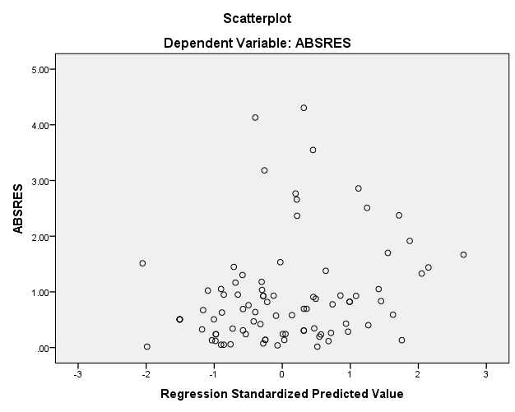

ANALISA REGRESI BERGANDA

REGRESSION
/MISSING LISTWISE
/STATISTICS COEFF OUTS R ANOVA
/CRITERIA=PIN(.05) POUT(.10)
/NOORIGIN
/DEPENDENT Kinerja
/METHOD=ENTER Supervisi Integritas Budaya_Org Etos_Kerja
/SCATTERPLOT=(Kinerja ,*ZPRED).

Regression

Notes
Output Created |  | 04-JUL-2021 16:21:13
Comments
Input | Data | D:\DATA S2\MBAK RENI\Data asumsi klasik.sav
 | Active Dataset | DataSet1
 | Filter | <none>
 | Weight | <none>
 | Split File | <none>
 | N of Rows in Working Data File | 90
Missing Value Handling | Definition of Missing | User-defined missing values are treated as missing.
 | Cases Used | Statistics are based on cases with no missing values for any variable used.
Syntax |  | REGRESSION  /MISSING LISTWISE  /STATISTICS COEFF OUTS R ANOVA  /CRITERIA=PIN(.05) POUT(.10)  /NOORIGIN  /DEPENDENT Kinerja  /METHOD=ENTER Supervisi Integritas Budaya_Org Etos_Kerja  /SCATTERPLOT=(Kinerja ,*ZPRED).
Resources | Processor Time | 00:00:00,91
 | Elapsed Time | 00:00:00,29
 | Memory Required | 4112 bytes
 | Additional Memory Required for Residual Plots | 0 bytes

Variables Entered/Removedª
Model | Variables Entered | Variables Removed | Method
1 | Etos_Kerja, Supervisi, Budaya_Org, Integritas^{b} | . | Enter
a. Dependent Variable: Kinerja
b. All requested variables entered.

Model Summary^{b}
Model | R | R Square | Adjusted R Square | Std. Error of the Estimate
1 | .709ª | .502 | .479 | 1.321
a. Predictors: (Constant), Etos_Kerja, Supervisi, Budaya_Org, Integritas
b. Dependent Variable: Kinerja

ANOVAª
Model |  | Sum of Squares | df | Mean Square | F | Sig.
1 | Regression | 149.670 | 4 | 37.417 | 21.427 | .000^{b}
 | Residual | 148.430 | 85 | 1.746
 | Total | 298.100 | 89
a. Dependent Variable: Kinerja
b. Predictors: (Constant), Etos_Kerja, Supervisi, Budaya_Org, Integritas

Coefficientsª
Model |  | Unstandardized Coefficients |  | Standardized Coefficients | t | Sig.
 |  | B | Std. Error | Beta
1 | (Constant) | 5.496 | 1.891 |  | 2.907 | .005
 | Supervisi | .062 | .098 | .059 | 2.634 | .028
 | Integritas | .479 | .115 | .499 | 4.166 | .000
 | Budaya_Org | .170 | .105 | .183 | 3.619 | .009
 | Etos_Kerja | .061 | .122 | .063 | 2.506 | .014
a. Dependent Variable: Kinerja

Residuals Statisticsª
 | Minimum | Maximum | Mean | Std. Deviation | N
Predicted Value | 19.88 | 24.50 | 22.10 | 1.297 | 90
Residual | -4.130 | 4.305 | .000 | 1.291 | 90
Std. Predicted Value | -1.714 | 1.847 | .000 | 1.000 | 90
Std. Residual | -3.126 | 3.258 | .000 | .977 | 90
a. Dependent Variable: Kinerja

Charts

