LAMPIRAN

LAMPIRAN 1
KUISIONER PENELITIAN
Kepada :
Yth. Bapak / Ibu
Pegawai Organisasi Perangkat Daerah (OPD) Pemerintah
Di Klaten
Saya Ety Imam Parawati, Mahasiswa Pascasarjana Fakultas Ekonomi Manajemen Universitas Islam Batik Surakarta sedang melaksanakan penelitian dalam rangka pengerjaan tesis yang berjudul “Kinerja Pegawai Organisasi Perangkat Daerah (OPD) Pemerintah Kabupaten Klaten”.
Responden saya adalah Pegawai Organisasi Perangkat Daerah (OPD) Pemerintah Kabupaten Klaten. Saya mohon kesediaan Bapak / Ibu untuk mengisi daftar kuisioner. Informasi yang Bapak / Ibu berikan hanya untuk data penelitian dalam penyusunan Tesis.
Atas kerjasamanya diucapkan terima kasih.
Peneliti,

Ety Imam Parawati
Data Responden
A. | Nama Responden | : | ………………………………
B. | Jenis Kelamin | : | - Laki-Laki  - Perempuan
C. | Usia | : | - 21 - 30 Tahun  - 31 - 40 Tahun | - 40 – 50 Tahun  - > 50 Tahun
D. | Pendidikan | : | - SMA  - DIII | - Sarjana  - Magister
E. | Pengalaman Kerja | : | - < 5 Tahun  - 6 – 10 Tahun | - 11 - 15 Tahun  - > 20 Tahun

Cara Pengisian
Pillihlah alternatif yang sesuai menurut pendapat Bapak/Ibu/sdr/i dan berikan tanda ceklist (√) pada kolom jawaban yang tersedia. Dengan pilihan alternatif jawaban sebagai berikut:
Singkatan | Keterangan | Skor
SS | Sangat Setuju | 5
S | Setuju | 4
KS | Kurang Setuju | 3
TS | Tidak Setuju | 2
STS | Sangat Tidak Setuju | 1

- Kinerja Pegawai
No. | Pernyatan | Alternatif Jawaban
 |  | SS  5 | S  4 | KS  3 | TS  2 | STS  1
1. | Bapak/Ibu/Saudara mampu menghasilkan pekerjaan yang terbaik.
2. | Mengerjakan pekerjaan tepat waktu.
3. | Bapak/Ibu Menyelesaikan pekerjaan tepat wakt Mampu mengatur dan menekan biaya yang digunakan dalam bekerja dengan baik.
4. | Maksimal dalam bekerja.
5. | Pegawai menjaga hubungan baik antar karyawan.

- Kepemimpinan
No. | Pernyatan | Alternatif Jawaban
 |  | SS  5 | S  4 | KS  3 | TS  2 | STS  1
1. | Pimpinan memiliki rasa kerendahan hati saat bekerja (tidak arogan).
2. | Pimpinan memiliki kejujuran dalam mejalankan pekerjaannya.
3. | Pimpinan memikili kesabaran yang tinggi dalam menyelesaikan masalah yang ada.
4. | Pimpinan mempunyai komitmen yang tinggi dalam bekerja.
5. | Pimpinan tidak pernah menutupi permasalahan yang ada kepada pegawainya.
- Motivasi
No. | Pernyatan | Alternatif Jawaban
 |  | SS  5 | S  4 | KS  3 | TS  2 | STS  1
1. | Pegawai melakukan pekerjaan dengan baik agar kebutuhannya tepenuhi.
2. | Bapak/Ibu/Saudara merasa nyaman ketika kebutuhan dan keselamatannya dapat dijamin.
3. | Kebutuhan sosial membuat pegawai menjadi lebih giat dalam bekerja.
4. | Pegawai merasa sangat senang ketika hasil kerjanya mendapat apresiasi.
5. | Bapak/Ibu/saudara menggunakan semua kemampuan dalam menjalankan pekerjaannya.

- Komunikasi
No. | Pernyatan | Alternatif Jawaban
 |  | SS  5 | S  4 | KS  3 | TS  2 | STS  1
1. | Memahami dengan baik maksud perkataan pimpinan dan teman kerja.
2. | Pegawai merasa senang ketika bisa berkomunikasi dengan atasan dan teman kerja.
3. | Sikap yang baik terhadap atasan dan teman kerja.
4. | Hubungan dengan atasan dan sesama rekan kerja telah tercipta dengan baik.
5. | Melakukan suatu tindakan tentang apa yang telah dikomunikasikan dengan atasan maupun teman kerja.

- Lingkungan Kerja
No. | Pernyatan | Alternatif Jawaban
 |  | SS  5 | S  4 | KS  3 | TS  2 | STS  1
1. | Tempat kerja Nyaman.
2. | Kondisi tempat kerja tenang.
3. | Tempat kerja memiliki fasilitas yang cukup memadai.
4. | Bapak/Ibu/saudara memiliki hubungan yang harmonis dengan atasan maupun sesama pegawai.
5. | Lingkungan tempat kerja sangat aman dari tindakan yang tidak diinginkan.
LAMPIRAN II
Data Scoring 20 Responden untuk Uji Instrumen
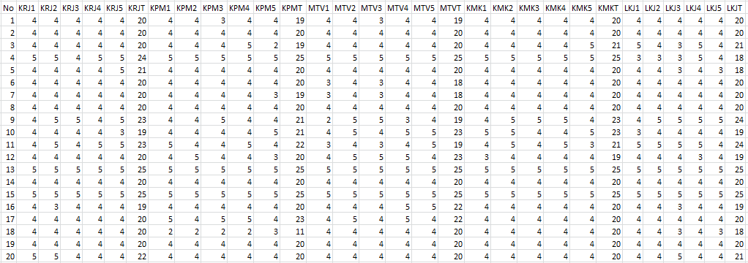

LAMPIRAN III
Data Scoring 59 Responden untuk Uji Asumsi Klasik dan Uji Hipotesis
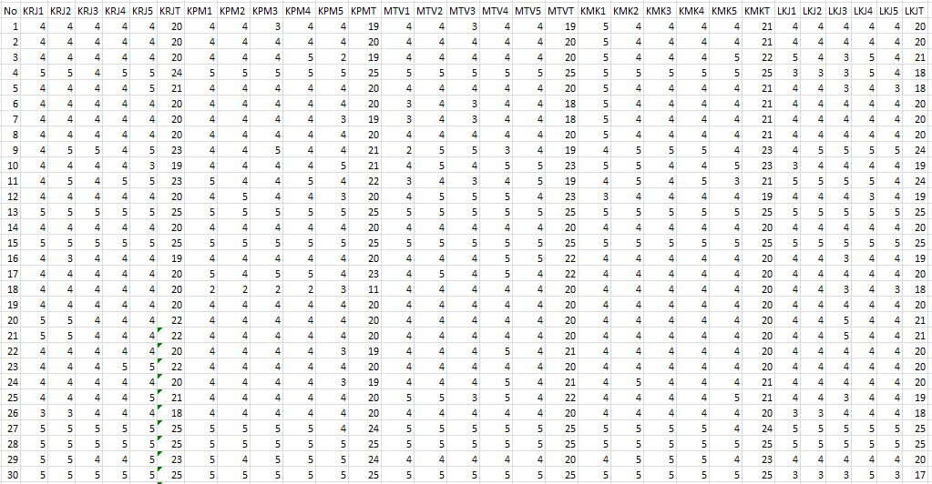
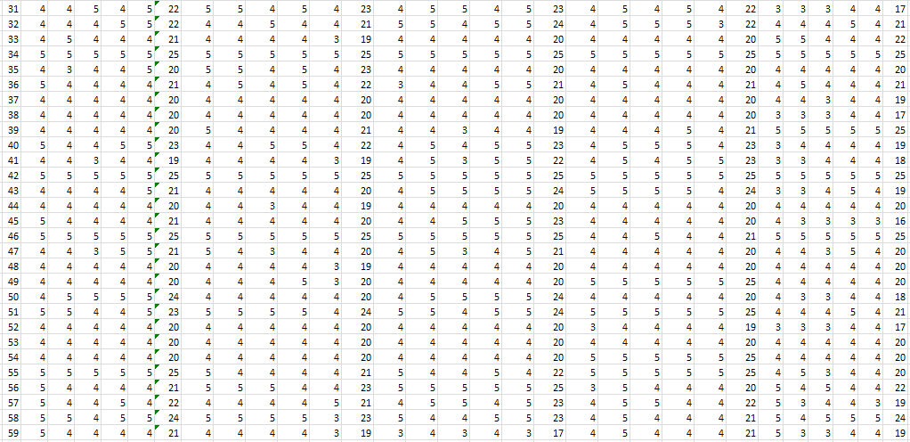

LAMPIRAN IV
Data Responden
Deskripsi Responden berdasarkan Jenis Kelamin
Jenis Kelamin | Jumlah | Persentase
Laki-laki | 30 | 51%
Perempuan | 29 | 49%
Total | 59 | 100%

Deskripsi Responden berdasarkan Umur
Usia | Jumlah | Persentase
21 - 30 Tahun | 13 | 22%
31 - 40 Tahun | 15 | 26%
40 – 50 Tahun | 22 | 37%
>50 Tahun | 9 | 15%
Total | 59 | 100%

Deskripsi Responden berdasarkan Pendidikan
Pendidikan | Jumlah | Persentase
SMA | 5 | 8%
DIII | 3 | 5%
Sarjana | 32 | 54%
Magister | 19 | 33%
Jumlah | 59 | 100%

Deskripsi Responden berdasarkan Pengalaman Kerja
Pekerjaan | Jumlah | Persentase
<5 Tahun | 14 | 23%
6 - 10 Tahun | 8 | 13%
11 - 15 Tahun | 13 | 22%
16 - 20 Tahun | 6 | 11%
>20 Tahun | 18 | 31%
Total | 59 | 100%

LAMPIRAN V
HASIL UJI INSTRUMEN

Hasil Uji Validitas Kinerja Pegawai

Correlations
 |  | KRJ1 | KRJ2 | KRJ3 | KRJ4 | KRJ5 | KRJT
KRJ1 | Pearson Correlation | 1 | .699** | .490* | .687** | .466* | .794**
 | Sig. (2-tailed) |  | .001 | .028 | .001 | .038 | .000
 | N | 20 | 20 | 20 | 20 | 20 | 20
KRJ2 | Pearson Correlation | .699** | 1 | .588** | .699** | .652** | .891**
 | Sig. (2-tailed) | .001 |  | .006 | .001 | .002 | .000
 | N | 20 | 20 | 20 | 20 | 20 | 20
KRJ3 | Pearson Correlation | .490* | .588** | 1 | .490* | .588** | .743**
 | Sig. (2-tailed) | .028 | .006 |  | .028 | .006 | .000
 | N | 20 | 20 | 20 | 20 | 20 | 20
KRJ4 | Pearson Correlation | .687** | .699** | .490* | 1 | .699** | .862**
 | Sig. (2-tailed) | .001 | .001 | .028 |  | .001 | .000
 | N | 20 | 20 | 20 | 20 | 20 | 20
KRJ5 | Pearson Correlation | .466* | .652** | .588** | .699** | 1 | .841**
 | Sig. (2-tailed) | .038 | .002 | .006 | .001 |  | .000
 | N | 20 | 20 | 20 | 20 | 20 | 20
KRJT | Pearson Correlation | .794** | .891** | .743** | .862** | .841** | 1
 | Sig. (2-tailed) | .000 | .000 | .000 | .000 | .000
 | N | 20 | 20 | 20 | 20 | 20 | 20
**. Correlation is significant at the 0.01 level (2-tailed).
*. Correlation is significant at the 0.05 level (2-tailed).

Hasil Uji Validitas Kepemimpinan

Correlations
 |  | KPM1 | KPM2 | KPM3 | KPM4 | KPM5 | KPMT
KPM1 | Pearson Correlation | 1 | .820** | .841** | .947** | .532* | .960**
 | Sig. (2-tailed) |  | .000 | .000 | .000 | .016 | .000
 | N | 20 | 20 | 20 | 20 | 20 | 20
KPM2 | Pearson Correlation | .820** | 1 | .778** | .779** | .444 | .881**
 | Sig. (2-tailed) | .000 |  | .000 | .000 | .050 | .000
 | N | 20 | 20 | 20 | 20 | 20 | 20
KPM3 | Pearson Correlation | .841** | .778** | 1 | .800** | .492* | .909**
 | Sig. (2-tailed) | .000 | .000 |  | .000 | .027 | .000
 | N | 20 | 20 | 20 | 20 | 20 | 20
KPM4 | Pearson Correlation | .947** | .779** | .800** | 1 | .319 | .888**
 | Sig. (2-tailed) | .000 | .000 | .000 |  | .171 | .000
 | N | 20 | 20 | 20 | 20 | 20 | 20
KPM5 | Pearson Correlation | .532* | .444 | .492* | .319 | 1 | .663**
 | Sig. (2-tailed) | .016 | .050 | .027 | .171 |  | .001
 | N | 20 | 20 | 20 | 20 | 20 | 20
KPMT | Pearson Correlation | .960** | .881** | .909** | .888** | .663** | 1
 | Sig. (2-tailed) | .000 | .000 | .000 | .000 | .001
 | N | 20 | 20 | 20 | 20 | 20 | 20
**. Correlation is significant at the 0.01 level (2-tailed).
*. Correlation is significant at the 0.05 level (2-tailed).

Hasil Uji Validitas Motivasi

Correlations
 |  | MTV1 | MTV2 | MTV3 | MTV4 | MTV5 | MTVT
MTV1 | Pearson Correlation | 1 | .255 | .438 | .718** | .405 | .777**
 | Sig. (2-tailed) |  | .279 | .054 | .000 | .076 | .000
 | N | 20 | 20 | 20 | 20 | 20 | 20
MTV2 | Pearson Correlation | .255 | 1 | .729** | .546* | .435 | .752**
 | Sig. (2-tailed) | .279 |  | .000 | .013 | .055 | .000
 | N | 20 | 20 | 20 | 20 | 20 | 20
MTV3 | Pearson Correlation | .438 | .729** | 1 | .362 | .277 | .755**
 | Sig. (2-tailed) | .054 | .000 |  | .116 | .237 | .000
 | N | 20 | 20 | 20 | 20 | 20 | 20
MTV4 | Pearson Correlation | .718** | .546* | .362 | 1 | .627** | .845**
 | Sig. (2-tailed) | .000 | .013 | .116 |  | .003 | .000
 | N | 20 | 20 | 20 | 20 | 20 | 20
MTV5 | Pearson Correlation | .405 | .435 | .277 | .627** | 1 | .678**
 | Sig. (2-tailed) | .076 | .055 | .237 | .003 |  | .001
 | N | 20 | 20 | 20 | 20 | 20 | 20
MTVT | Pearson Correlation | .777** | .752** | .755** | .845** | .678** | 1
 | Sig. (2-tailed) | .000 | .000 | .000 | .000 | .001
 | N | 20 | 20 | 20 | 20 | 20 | 20
**. Correlation is significant at the 0.01 level (2-tailed).
*. Correlation is significant at the 0.05 level (2-tailed).

Hasil Uji Validitas Komunikasi

Correlations
 |  | KMK1 | KMK2 | KMK3 | KMK4 | KMK5 | KMKT
KMK1 | Pearson Correlation | 1 | .709** | .629** | .545* | .699** | .869**
 | Sig. (2-tailed) |  | .000 | .003 | .013 | .001 | .000
 | N | 20 | 20 | 20 | 20 | 20 | 20
KMK2 | Pearson Correlation | .709** | 1 | .764** | .882** | .385 | .887**
 | Sig. (2-tailed) | .000 |  | .000 | .000 | .094 | .000
 | N | 20 | 20 | 20 | 20 | 20 | 20
KMK3 | Pearson Correlation | .629** | .764** | 1 | .866** | .539* | .897**
 | Sig. (2-tailed) | .003 | .000 |  | .000 | .014 | .000
 | N | 20 | 20 | 20 | 20 | 20 | 20
KMK4 | Pearson Correlation | .545* | .882** | .866** | 1 | .226 | .823**
 | Sig. (2-tailed) | .013 | .000 | .000 |  | .337 | .000
 | N | 20 | 20 | 20 | 20 | 20 | 20
KMK5 | Pearson Correlation | .699** | .385 | .539* | .226 | 1 | .704**
 | Sig. (2-tailed) | .001 | .094 | .014 | .337 |  | .001
 | N | 20 | 20 | 20 | 20 | 20 | 20
KMKT | Pearson Correlation | .869** | .887** | .897** | .823** | .704** | 1
 | Sig. (2-tailed) | .000 | .000 | .000 | .000 | .001
 | N | 20 | 20 | 20 | 20 | 20 | 20
**. Correlation is significant at the 0.01 level (2-tailed).
*. Correlation is significant at the 0.05 level (2-tailed).

Hasil Uji Validitas Lingkungan Kerja

Correlations
 |  | LKJ1 | LKJ2 | LKJ3 | LKJ4 | LKJ5 | LKJT
LKJ1 | Pearson Correlation | 1 | .720** | .394 | .433 | .355 | .728**
 | Sig. (2-tailed) |  | .000 | .086 | .057 | .125 | .000
 | N | 20 | 20 | 20 | 20 | 20 | 20
LKJ2 | Pearson Correlation | .720** | 1 | .741** | .440 | .601** | .892**
 | Sig. (2-tailed) | .000 |  | .000 | .052 | .005 | .000
 | N | 20 | 20 | 20 | 20 | 20 | 20
LKJ3 | Pearson Correlation | .394 | .741** | 1 | .264 | .711** | .820**
 | Sig. (2-tailed) | .086 | .000 |  | .261 | .000 | .000
 | N | 20 | 20 | 20 | 20 | 20 | 20
LKJ4 | Pearson Correlation | .433 | .440 | .264 | 1 | .515* | .660**
 | Sig. (2-tailed) | .057 | .052 | .261 |  | .020 | .002
 | N | 20 | 20 | 20 | 20 | 20 | 20
LKJ5 | Pearson Correlation | .355 | .601** | .711** | .515* | 1 | .814**
 | Sig. (2-tailed) | .125 | .005 | .000 | .020 |  | .000
 | N | 20 | 20 | 20 | 20 | 20 | 20
LKJT | Pearson Correlation | .728** | .892** | .820** | .660** | .814** | 1
 | Sig. (2-tailed) | .000 | .000 | .000 | .002 | .000
 | N | 20 | 20 | 20 | 20 | 20 | 20
**. Correlation is significant at the 0.01 level (2-tailed).
*. Correlation is significant at the 0.05 level (2-tailed).

Uji Reliabilitas Kinerja Pegawai
Reliability Statistics
Cronbach's Alpha | N of Items
.879 | 5

Uji Reliabilitas Kepemimpinan
Reliability Statistics
Cronbach's Alpha | N of Items
.908 | 5

Uji Reliabilitas Motivasi
Reliability Statistics
Cronbach's Alpha | N of Items
.810 | 5

Uji Reliabilitas Komunikasi
Reliability Statistics
Cronbach's Alpha | N of Items
.886 | 5

Uji Reliabilitas Lingkungan Kerja
Reliability Statistics
Cronbach's Alpha | N of Items
.832 | 5

LAMPIRAN VI
UJI ASUMSI KLASIK

Uji Normalitas
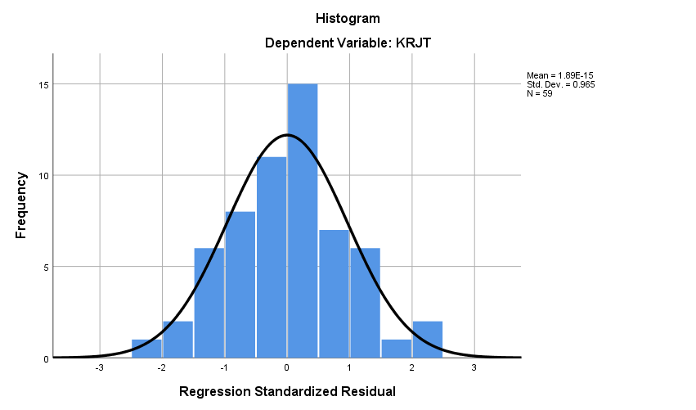

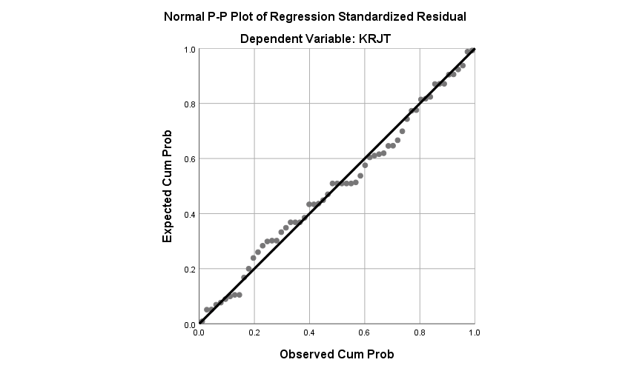

One-Sample Kolmogorov-Smirnov Test
 |  | Unstandardized Residual
N |  | 59
Normal Parameters^{a,b} | Mean | .0000000
 | Std. Deviation | 1.17410916
Most Extreme Differences | Absolute | .062
 | Positive | .062
 | Negative | -.056
Test Statistic |  | .062
Asymp. Sig. (2-tailed) |  | .200^{c,d}
a. Test distribution is Normal.
b. Calculated from data.
c. Lilliefors Significance Correction.
d. This is a lower bound of the true significance.

Uji Multikolinearitas

Coefficientsª
Model |  | Unstandardized Coefficients |  | Standardized Coefficients | Collinearity Statistics
 |  | B | Std. Error | Beta | Tolerance | VIF
1 | (Constant) | 2.158 | 2.073
 | KPMT | .205 | .101 | .246 | .436 | 2.295
 | MTVT | .270 | .100 | .279 | .536 | 1.864
 | KMKT | .223 | .101 | .290 | .630 | 1.588
 | LKJT | .213 | .076 | .200 | .740 | 1.351
a. Dependent Variable: KRJT

Uji Heterokedastisitas
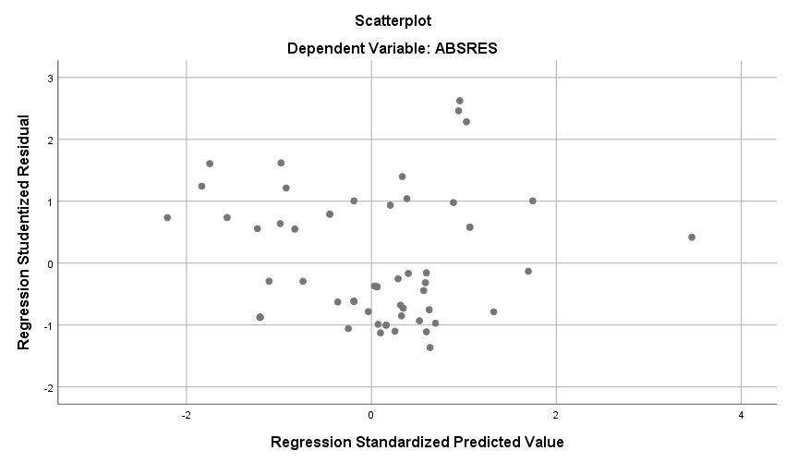

Coefficientsª
Model |  | Unstandardized Coefficients |  | Standardized Coefficients | t | Sig.
 |  | B | Std. Error | Beta
1 | (Constant) | .842 | 1.266 |  | .665 | .509
 | KPMT | -.087 | .062 | -.281 | -1.229 | .224
 | MTVT | .071 | .061 | .210 | .557 | .580
 | KMKT | .037 | .062 | .097 | .857 | .395
 | LKJT | -.020 | .047 | -.067 | -1.195 | .237
a. Dependent Variable: ABSRES

LAMPIRAN VII
HASIL UJI HIPOTESIS

Uji Regresi Linear Berganda

Coefficientsª
Model |  | Unstandardized Coefficients |  | Standardized Coefficients | t | Sig.
 |  | B | Std. Error | Beta
1 | (Constant) | 2.158 | 2.073 |  | 1.191 | .239
 | KPMT | .205 | .101 | .246 | 2.056 | .045
 | MTVT | .270 | .100 | .279 | 2.746 | .008
 | KMKT | .223 | .101 | .290 | 2.168 | .035
 | LKJT | .213 | .076 | .200 | 2.769 | .008
a. Dependent Variable: KRJT

Uji F

ANOVAª
Model |  | Sum of Squares | df | Mean Square | F | Sig.
1 | Regression | 140.875 | 4 | 35.219 | 24.785 | .000^{b}
 | Residual | 83.362 | 54 | 1.544
 | Total | 224.237 | 58
a. Dependent Variable: KRJT
b. Predictors: (Constant), LKJT, MTVT, KMKT, KPMT

Uji t
Coefficientsª
Model |  | Unstandardized Coefficients |  | Standardized Coefficients | t | Sig.
 |  | B | Std. Error | Beta
1 | (Constant) | 2.158 | 2.073 |  | 1.191 | .239
 | KPMT | .205 | .101 | .246 | 2.056 | .045
 | MTVT | .270 | .100 | .279 | 2.746 | .008
 | KMKT | .223 | .101 | .290 | 2.168 | .035
 | LKJT | .213 | .076 | .200 | 2.769 | .008
a. Dependent Variable: KRJT

Uji Koefisien Determinasi

Model Summary^{b}
Model | R | R Square | Adjusted R Square | Std. Error of the Estimate | Durbin-Watson
1 | .805ª | .647 | .621 | 1.21682 | 2.825
a. Predictors: (Constant), LKJT, MTVT, KMKT, KPMT
b. Dependent Variable: KRJT

LAMPIRAN VIII
Tabel r, Tabel F dan Tabel t

